In this assignment you will modify a PyDev project in Eclipse. Fork this project to your GitHub repo, then import it into Eclipse on your Desktop. Rename the project according to our standard.

<https://github.com/nicomp42/Midterm-Spring-2023-IS4010-001>

The program plays a video game, although not a very good one. You win the game about 50% of the time and about 1% of the time it crashes. Your job is to modify main.py:

1. Handle the crash so your program completes properly.
2. Print the helpful message as described in Figure 1. The message must print only one time!

Do not edit the code in videoGame.py.

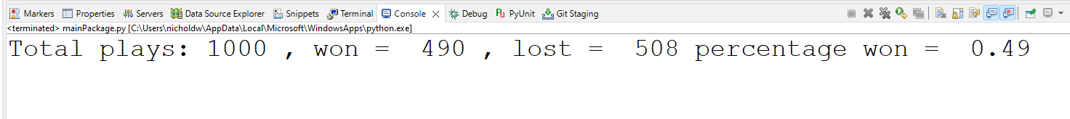

Figure 1 : Required output of the program. Your numbers will differ.

Rename the project to conform to our naming requirements. Do not rename any folders.

Submit your submission to Canvas according to our standards.